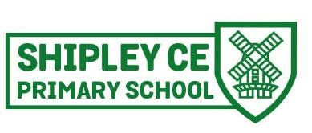

Friendship, Faith, Future

MATHS AT SHIPLEY

SUBJECT: MATHS
NATIONAL CURRICULUM

Purpose of study
Mathematics is a creative and highly inter-connected discipline. It is essential to everyday life, critical to science, technology, and engineering, and necessary for financial literacy and most forms of employment. A high-quality mathematics education therefore provides a foundation for understanding the world, the ability to reason mathematically and fosters a sense of curiosity, ready for the next stage of learning.
Aims
The national curriculum for mathematics aims to ensure that all pupils:
- become fluent in the fundamentals of mathematics, including through varied and frequent practice with increasingly complex problems over time, so that pupils develop conceptual understanding and the ability to recall and apply knowledge rapidly and accurately.
- reason mathematically by following a line of enquiry, conjecturing relationships, and generalisations, and developing an argument, justification or proof using mathematical language.
- can solve problems by applying their mathematics to a variety of routine and nonroutine problems with increasing sophistication, including breaking down problems into a series of simpler steps and persevering in seeking solutions.

The programmes of study are organised into distinct domains, but pupils should make rich connections across mathematical ideas to develop fluency,
mathematical reasoning, and competence in solving increasingly sophisticated problems. We use mastery planning to embed mathematical concepts and we
follow the White Rose maths scheme, that deepens our children’s understanding to extend fluency, reasoning and problem solving. Children should also
apply their mathematical knowledge to science and other subjects.

INTENT
Every pupil is valued for their contribution and for their strengths and interests. As a result, we aim to ensure that every child achieves success and that all are
enabled to develop their skills in accordance with their level of ability in accordance with our School Vision:
“We are a welcoming and inclusive family school at the heart of the community. Our shared journey of discovery, knowledge and faith is with God and we celebrate ‘life in all its fullness’ (John 10:10). We strive to value the uniqueness of each child, unlocking their God-given potential and ensuring they are inspired to keep learning. We want children to flourish, cope with success and challenge with perseverance and determination in order to be fully prepared for the next phase of their education.”
Mathematics is both a key skill within school, and a life skill. It equips pupils with a powerful set of tools to understand the world around them. These tools include fluency, logical reasoning, problem solving skills and the ability to think in abstract ways. Our curriculum is designed to ensure that children develop a positive and enthusiastic attitude towards mathematics that will stay with them for life.

Mastery
Pupils are required to explore maths in depth, using mathematical vocabulary to reason and explain their workings. A wide range of mathematical resources are used, and pupils are taught to show their workings in a concrete, pictorial and abstract form wherever suitable. They are taught to explain their choice of methods and develop their mathematical reasoning skills. We encourage resilience, adaptability, and acceptance that sometimes we will face mathematical challenges but we will learn and grow from them.

High Expectations  All children are expected to succeed and make progress from their starting points. | Modelling  Teachers teach the skills needed to succeed in mathematics providing examples of good practice and having high expectations. | A Vocabulary Rich Environment  Mathemtical talk for is a key learning tool. Pre-teaching and modelling the use of key vocabulary is a driver for pupil understanding and develops the confidence of pupils to explain mathematically. | Pattern and Connection Identification  All children will have opportunities to identify patterns or connections in their maths; they can use this to predict and reason and to also develop their own patterns or links in maths and other subjects.

Fluency  Pupils should become fluent in the fundamentals of mathematics, developing conceptual understanding and the ability to recall and apply knowledge rapidly and accurately. | Reasoning  Pupils should be able to reason mathematically, following a line of enquiry, making parallels and generalisations and using mathematical language to developing an argument, justification or proof. | The Teaching of Problem Solving  Pupils should be able to solve problems by applying their mathematics to a variety of routine and non-routine problems, including breaking down problems into a series of simpler steps and persevering in seeking solutions. | Mastery  Children should be secure in their long-term, deep and adaptable understanding of maths which they can apply in different contexts.

EYFS
Number ELG
Children at the expected level of development will:
- Have a deep understanding of number to 10, including the composition of each number.
- Subitise (recognise quantities without counting) up to 5.
- Automatically recall (without reference to rhymes, counting or other aids) number bonds up to 5 (including subtraction facts) and some number bonds to 10, including double facts.

Numerical Patterns ELG
Children at the expected level of development will:
- Verbally count beyond 20, recognising the pattern of the counting system.
- Compare quantities up to 10 in different contexts, recognising when one quantity is greater than, less than or the same as the other quantity.
- Explore and represent patterns within numbers up to 10, including evens and odds, double facts and how quantities can be distributed equally.

IMPLEMENTATION

White Rose & Deepening Understanding  Every class from EYFS to Y6 follows the White Rose scheme of learning which follows the objectives set out in the National Curriculum. Lessons may be adapted or personalised to address the individual needs and requirements for the class but overall coverage is maintained. This is supplemented by a range of planning resources including those provided by the NCETM and NRICH. | Online Maths Tools  Times Tables Rock Stars is used for multiplication practise, application and consolidation of all units. www.maths.co.uk is used for reasoning, problem solving and diagnostic assessments | Assessment  Pupils progress against is measured against expected attainment for their age, making formative assessment notes where appropriate and using these to inform teaching. Discussions in termly pupil progress meetings, staff CPD, moderation form the basis of provision and interventions  www.maths.co.uk is used for diagnostic assessments
Concrete, Pictorial, Abstract (CPA)  We implement our approach through high quality teaching which delivers appropriately challenging work for all individuals. To support us, we have a range of mathematical resources in the classrooms including Numicon, Base 10 and counters (concrete equipment). When children have grasped a concept using concrete equipment, images and diagrams are used (pictorial) prior to moving to abstract questions. Abstract maths relies on the children understanding a concept  thoroughly and being able to use their knowledge  and understanding to answer and solve maths without equipment or images. | Continuing Professional Development (CPD)  CPD is an integral element of the school improvement process. Staff take part in on site training, monitoring and pupil conferencing as part of subject leadership.  Staff also take part in national training - NPQ level and below to ensure the school is up to date with the latest research and development in the teaching and leading of maths | Cross Curricular  Maths is taught across the curriculum ensuring that skills taught in maths lessons are applied in other subjects particularly those that involve elements of real life maths, such as science and design technology.

Pupils are provided with a variety of opportunities to develop and extend their mathematical skills in and across each phase of education. Maths is taught
following the National Curriculum 2014, the West Sussex guidelines and appropriate teaching resources within a Mastery approach to ensure they are secure
in the key concepts of mathematics, appropriate for their age group. Gaps in their understanding that provide barriers to learning are identified early and
appropriate interventions provided.
‘A mathematical concept or skill has been mastered when, through exploration, clarification, practice and application over time, a person can represent it in multiple ways, has the mathematical language to be able to communicate related ideas, and can think mathematically with the concept so that they can independently apply it to a totally new problem in an unfamiliar situation.’
¹ Mastering Mathematics: Teaching to transform achievement, Dr Helen Drury.

Children (except EYFS) are taught in mixed age classes and work is differentiated to suit the needs of the various levels of ability and year groups. There are some opportunities for single age teaching at Y2 and Y6. There are opportunities for group work, paired work, individual work and whole class teaching.
Within mathematics lessons, through careful planning and preparation, pupils engage in:
  - the development of mental strategies
  - written methods
  - practical activities and mathematical games
  - investigational work
  - problem solving and reasoning
  - mathematical discussion
  - consolidation of basic skills and number facts
  - Working with computers as a mathematical tool.
Teachers recognise the importance of establishing a secure foundation in mental calculation and recall of number facts before standard written methods are introduced. Maths is timetables daily and pupil have the opportunities to develop and apply these skills across the curriculum.

Disadvantaged and SEND pupils are at the heart of all planning sequences in the school. Like with every other lesson, a range of scaffolds, differentiation and support strategies are used to ensure equal access to the curriculum. Strategies include but are not limited to access to concrete and pictorial apparatus, visual aids and photographs, modelling the use of vocabulary, pre-learning and over learning vocabulary and concepts, partner work and multi-sensory learning.

BUILDING KNOWLEDGE AND UNDERSTANDING IN MATHS

See National Curriculum and White Rose progression of skills documents.

MATHS LONG TERM PLAN
EYFS

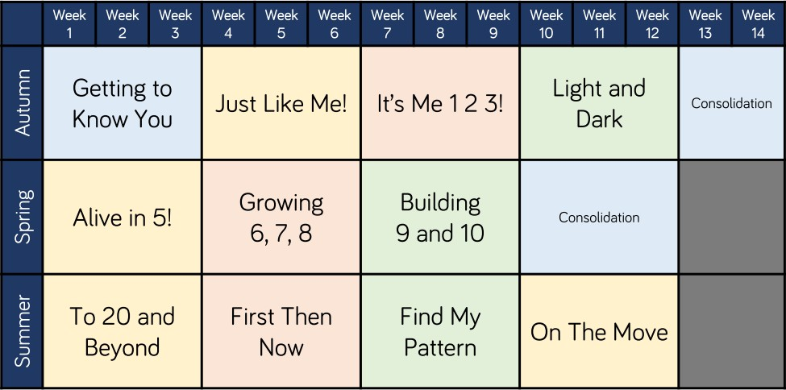

Year 1/2

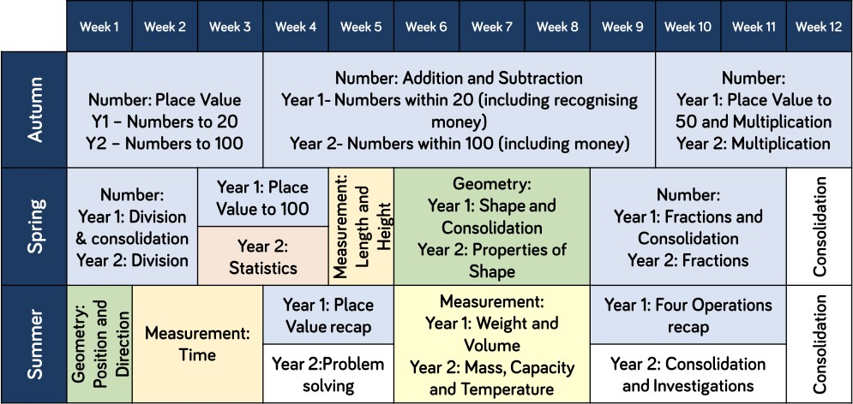

Year 3/4

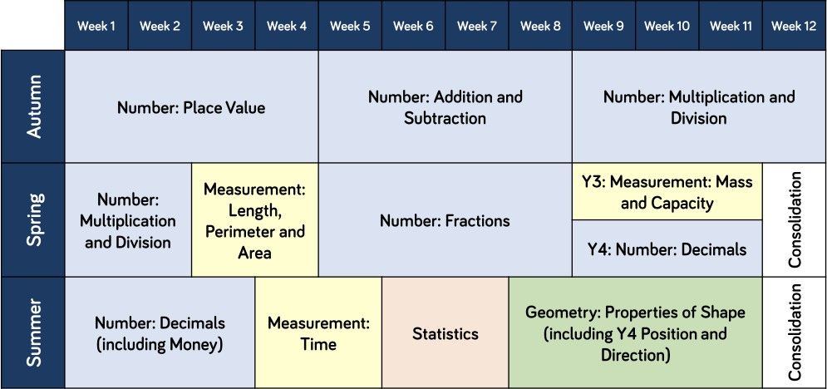

Year 5/6

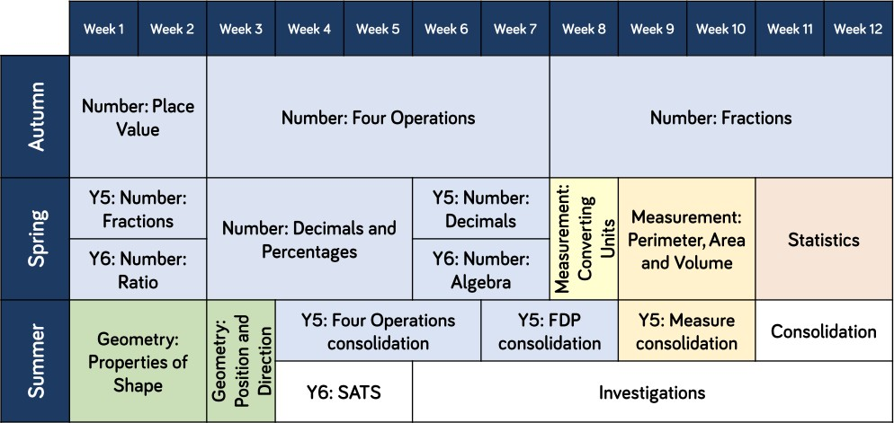

IMPACT

Pupil Voice  Through discussion and feedback, children talk enthusiastically and passionately about their maths lessons and speak about how they love learning about maths. They can articulate the context in which maths is being taught and relate this to real life purposes.  Children show confidence and believe they can learn about a new maths area and apply the knowledge and skills they already have. | Evidence in Knowledge  Pupils know how and why maths is used in the outside world and in the workplace. They know about different ways that maths can be used to support their future potential.  Mathematical concepts or skills are mastered when a child can show it in multiple ways, using mathematical vocabulary to explain their ideas, and can independently apply the concept to new problems in unfamiliar situations.  Children demonstrate a quick recall of the facts and procedures. This includes recollection of all times tables. | Evidence in Skills  Pupils use acquired vocabulary in maths lessons. They have the skills to use methods independently and show resilience when tackling problems.  The flexibility and fluidity to move between different contexts and representations of maths.  Children show pride in the presentation and understanding of the work.  The chance to develop the ability to recognise the relationships and make connections in maths lessons.  Teachers plan a range of opportunities to use maths in the classroom and outdoors too. | Outcomes  At the end of each year, we assess pupils against age related expectations for their year group. Some children will have progressed further and achieved greater depth. Children who have gaps in their knowledge receive appropriate support and interventions.  Mastery  The aim is to secure long term, deep and adaptable understanding of maths which pupils can apply in different contexts.

Assessment

To develop learning, pupils will be continuously assessed using a variety of strategies – observation, questioning, marking in accordance to our school Assessment for Learning policy In EYFS, pupils will be assessed and the Foundation profile completed throughout the year.
Teachers mark children’s work in line with the Feedback and Learning policy . Information collected through marking about individual successes or misconceptions (formative assessment information) will influence what is taught in following lessons, and may result in planning adaptations.

Statutory Assessment at Shipley Primary School

- EYFS: Children are assessed in The Early Learning Goals (ELGs) in the three prime areas of learning (communication and language; physical development; and personal, social and emotional development) and the ELGs in the specific areas of mathematics and literacy
- Year 4: Children will undertake a Mathematics Times Tables Check. The purpose of the MTC is to determine whether year 4 pupils can recall their multiplication tables fluently. The children will be tested using an on-screen check answering answer multiplication questions in six seconds.
- Year 6 children take end of Key Stage 2 SATs which assess their mathematical skills and knowledge. This consists of 2 components as in Key Stage 1 (arithmetic and reasoning) but there are 3 papers in total (2 reasoning papers and 1 arithmetic paper).

